Year 4 – Term 1 Spellings
Test  5.9.25  Homophones | 
Test  12.9.25  Prefix ‘in’ meaning not | 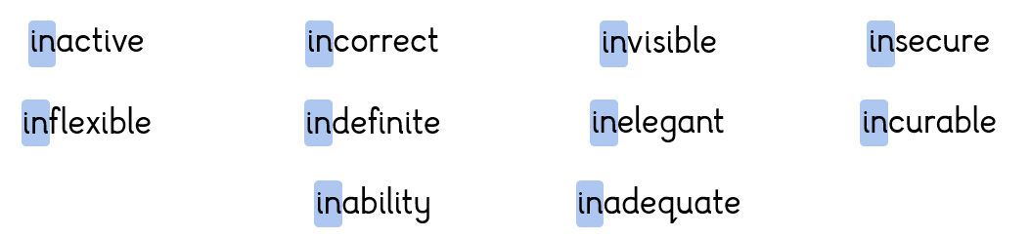
Test  19.9.25  Prefix ‘il’, ‘im’, ‘ir’ | 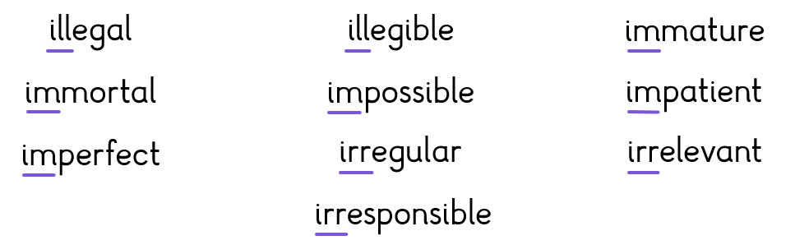
Test  26.9.25  Prefix ‘sub’ meaning below | 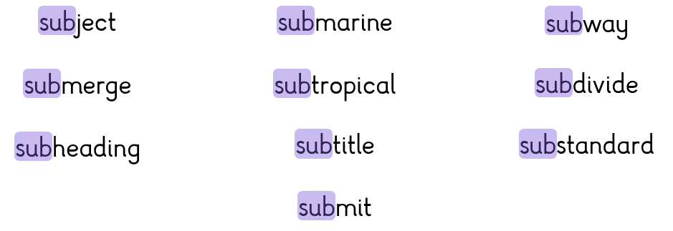
Test  03.10.25  Prefix ‘inter’ meaning between | 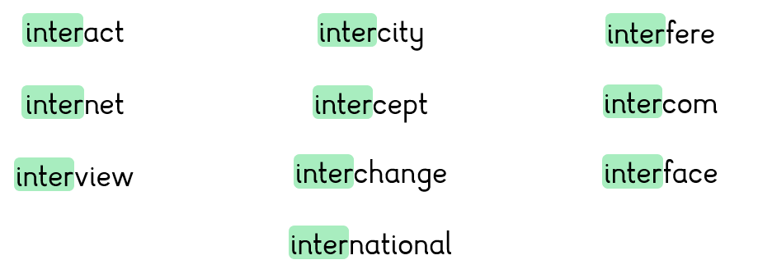
Test  10.10.25  Challenge Words | 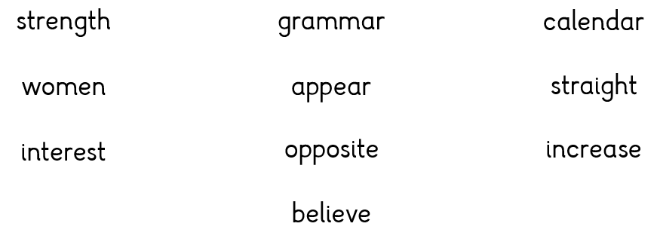
Test  17.10.25  Recap of Term | A mixture of all of the above words.

