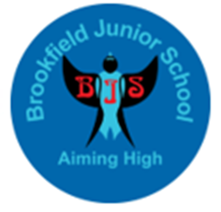
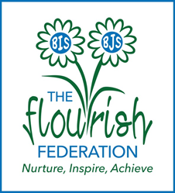

Brookfield Junior School
Mathematics Vocabulary Progression Document

We ensure the teaching and introduction of new Mathematical vocabulary is progressive and key to the children’s understanding and ability to explore and explain their learning. This document is designed to assist with the teaching of vocabulary across the junior school and is aligned with the White Rose schemes of learning. This document identifies in which year group vocabulary should be explicitly taught and introduced. However, language should be revisited in subsequent year groups to ensure children are consolidating their understanding.



